Part 1:
(a new method I learned for this exercise from a YouTube video)
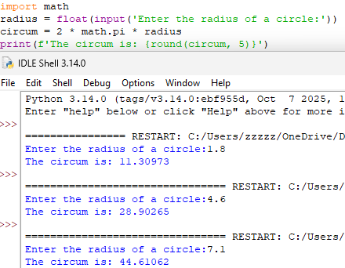
(my own way that I made before learning enough about math module)
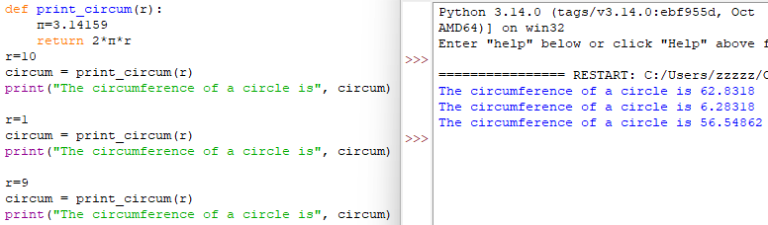
The function, print_circum(), calculates the circumference of a circle using the mathematical formula C = 2πr. This function takes one parameter - “a name used inside a function to refer to the value passed as an argument” (Downey, 2015) - the radius of the circle (‘r’). Inside this function, the constant value of the variable ‘π’ is 3.14159, as given in the assignment. Then, it calculates the circumference by 2πr. Instead of printing the result inside the function, the function uses the return() statement (keyword) to send the calculated value back. This way we can use this returned value outside the function.
After that, we call the program with different values of ‘r’. Each time the same process is repeated: it assigns the value to ‘r’, calculates circum, and prints the correct answer for the exact radius.

Part 2:
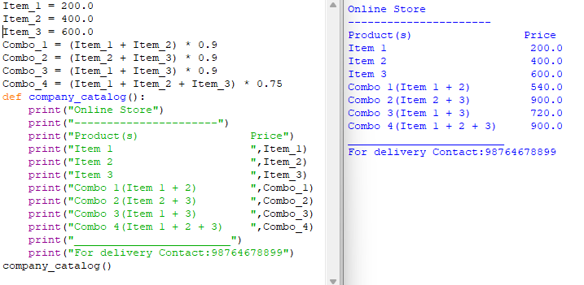
I started by setting the prices of the three items: 200.0, 400.0 and 600.0. Then I calculated each combo directly. Any two-item combo is multiplied by 0.9 for the 10% discount. The combo with all three items is multiplied by 0.75 for the 25% discount.
After the calculations, I defined a function called company_catalog(). As we know from Think Python: “Function definition is a statement that creates a new function, specifying its name, parameters, and the statements it contains (Downey, 2015).” In my program, the function doesn’t calculate anything new. It just prints the pre-calculated single item prices and combo prices. Then, at the end of the code, I call company_catalog() to display output exactly as stated in assignment.
My approach is doing the math first, then using a function to display results. Variables ‘remember’ the prices, arithmetic handles the discounts, and the function just outputs the results.
What features my function illustrates:
- Use of variables to store item prices and combo totals.
- Use of arithmetic operations to calculate discounts directly.
- Use of functions to organize code and display results.

